Computer Science The Garabge Collector GW Part 2 – The Game Lab Value - 100

Lab Goal : This lab was designed to teach you more object oriented programming and how to write a very simple game using recursion and graphics.

Lab Description : Remove all of the trash from the streets. The orange cells are the parts of the city that have trash and the empty green cells are clean parts of the city. A block or area of trash is any continuous group of orange cells connected either horizontal or vertical to another adjacent orange cell. Once you select a piece of trash ( an orange cell ), pick it up and all other pieces of trash that are touching it up, down, left, or right.
algorithm help

if ( r and c are in bounds and cell is on )
turn cell off
4 recursive calls up down left right

Sample Output :
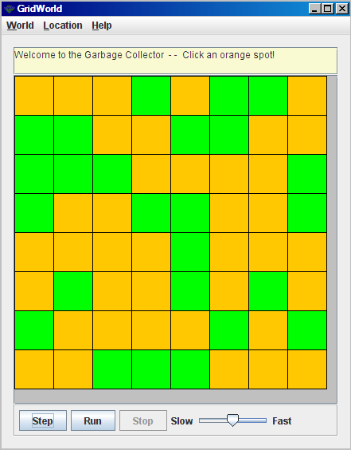

This trash block
contains one cell.

This trash block
contains four cells.

You will click your mouse on the trash you wish to pick up and the trash will disappear. All trash touching the clicked cell ( up, down, left, or right ) will be removed along with the cell you clicked.

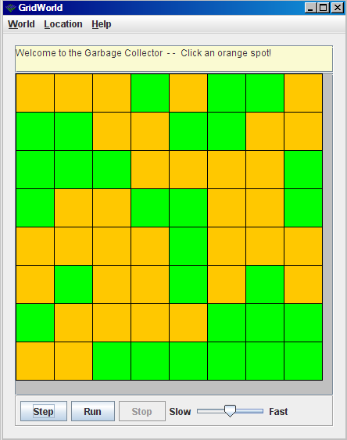

Files Needed ::
ColoredCell.java
GarbageCollector.java
GarbageRunner.java

The trash has been picked up.
BONUS ::

As you remove the trash, change each cell to blue so that you can follow the path of the recursion around as it moves around the screen.

You may need to modify the ColoredCell class so it can handle another Color.

